**Project Development Phase**

**Sprint - 2**

|  |  |
| --- | --- |
| Date | 19th November 2022 |
| Team ID | PNT2022TMID47097 |
| Project Name | Deep Learning Fundus Image Analysis for Early Detection of Diabetic Retinopathy |

# Sprint Plan

Define the initial stages of the problem requirement.

Draw and understand the flowchart of the sprint

Assign tasks to each teammate

# Team Tasks

* As a user, I can register for the application through mail
* Validate login
* Prediction part

# Progress

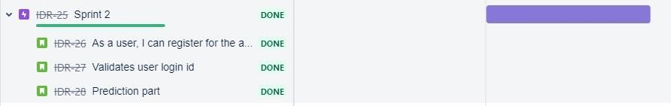

# Sprint tracker

start date end date current sprint points

31 Oct 2022 05 Nov 2022 16

# Velocity for Sprint-2 = 20/8 = 2.5 Code Snippet

model = load_model(r"Updated-xception-diabeticretinopathy*.*h5") app = Flask(__name__) app.secret_key="abc" app.config['UPLOAD_FOLDER'] = "User_Images"

|  |
| --- |
| @ app.route('/login', *methods*=['GET','POST']) def login(): if request.method == "GET":  user = request.args.get('mail') passw = request.args.get('pass') print(user, passw) query = {'mail': {'$eq': user}} docs = my_database.get_query_result(query) print(docs) print(len(docs.all())) if (len(docs.all()) == 0): return render_template('login.html', *pred*="") else: if ((user == docs[0][0]['mail'] and passw == docs[0][0]['psw'])): session['user'] = user flash("Logged in as " + str(user)) return render_template('index.html', *pred*="Logged in as "+str(user), *vis* ="hidden", *vis2*="visible") else:  return render_template('login.html', *pred*="The password is wrong.") else:  return render_template('login.html') |

# Test cases

|  |  |
| --- | --- |
| **Test cases** | **Result** |
| Improper mail id given | Not registered |
| Password not provided | Not logged in |
| Log in to the application | Successful |
| Showing logged in mail id | Successful |
| Upload and correct prediction | Successful (logged in as abc@gmail.com) |

# Result

